

# ADDIS ABABA INSTITUTE OF TECHNOLOGY CENTER OF INFORMATION TECHNOLOGY AND SCIENTIFIC COMPUTING

# PkI lab

## Prepared by: - Amanuel Genene

ID: - ATE/5124/09

Submitted to: Mr. Abraham

## Task2.1: Becoming a Certiﬁcate Authority(CA)

First we create the required directories and files.

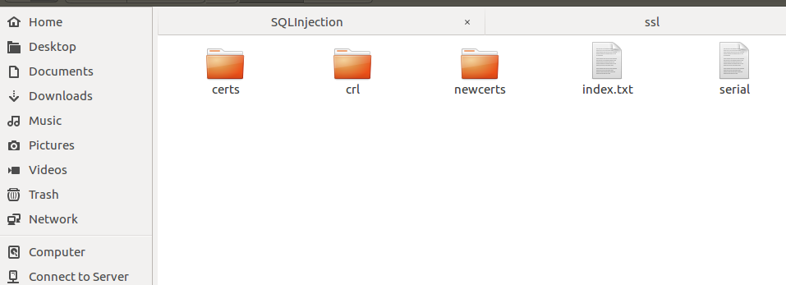

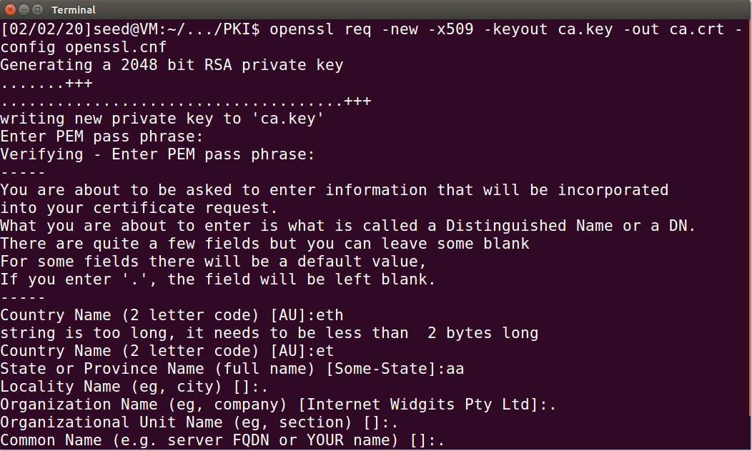

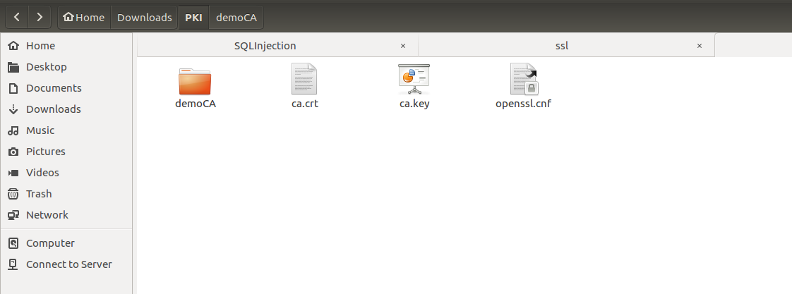

## Task2.2: Creating a Certiﬁcate for SEEDPKILab2018.com

We can run the following command to generate an RSA key pair (both private and public keys).

Then we print out the encoded server.key file.

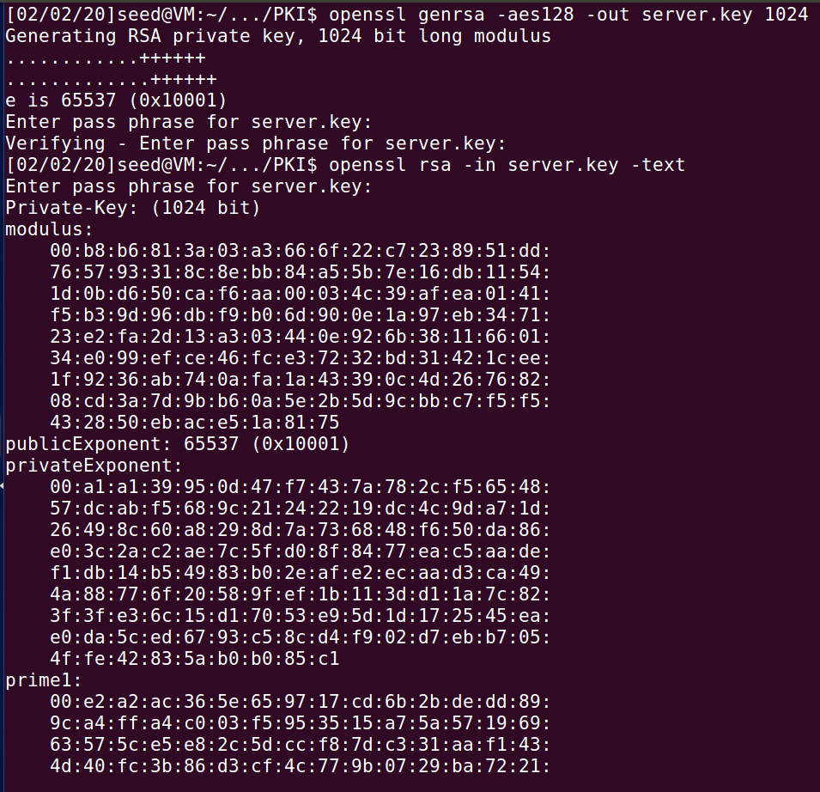

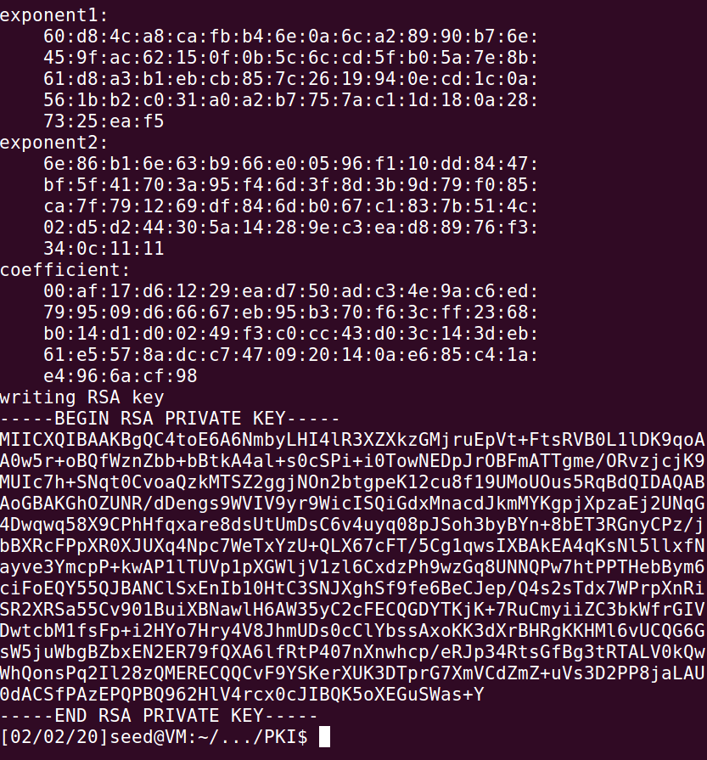

After the company has the key file, it generates Certiﬁcate Signing Request (CSR) file, which basically includes the company’s public key.

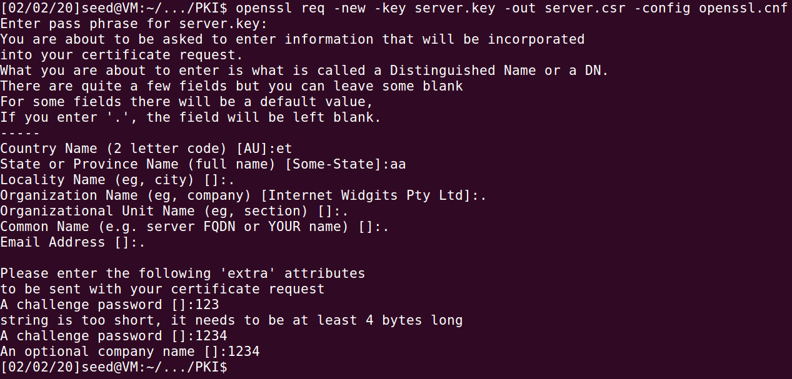

We execute the command to issuing certificates.

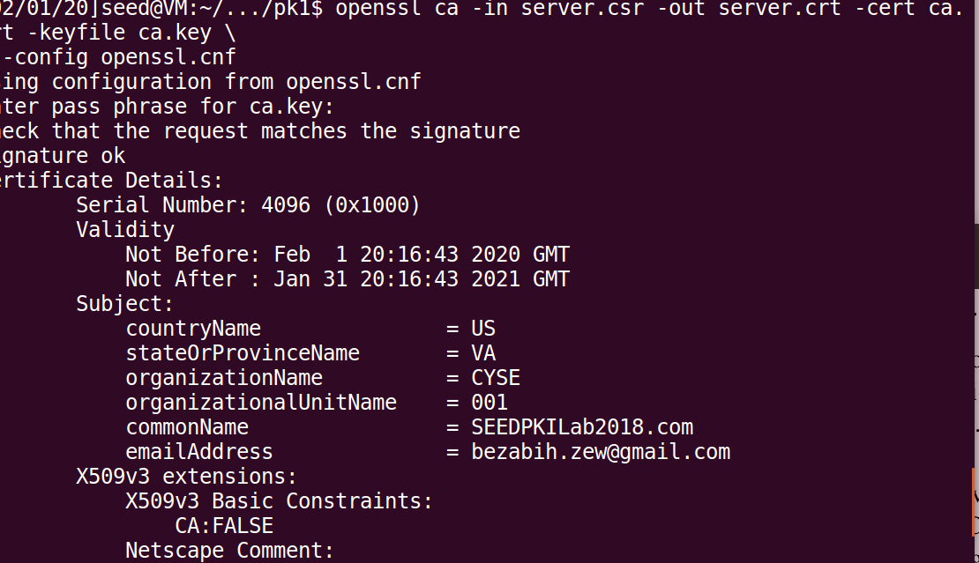

## Task2.3: Deploying Certiﬁcate in an HTTPSWebServer

**Step 1 Conﬁguring the web server.**



Second then coSpy the certificates



Start the service by using this command.

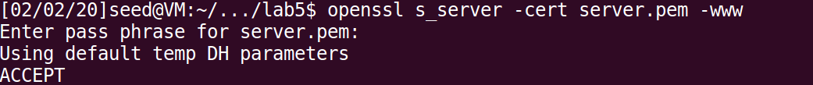

## Try the HTTPS website

